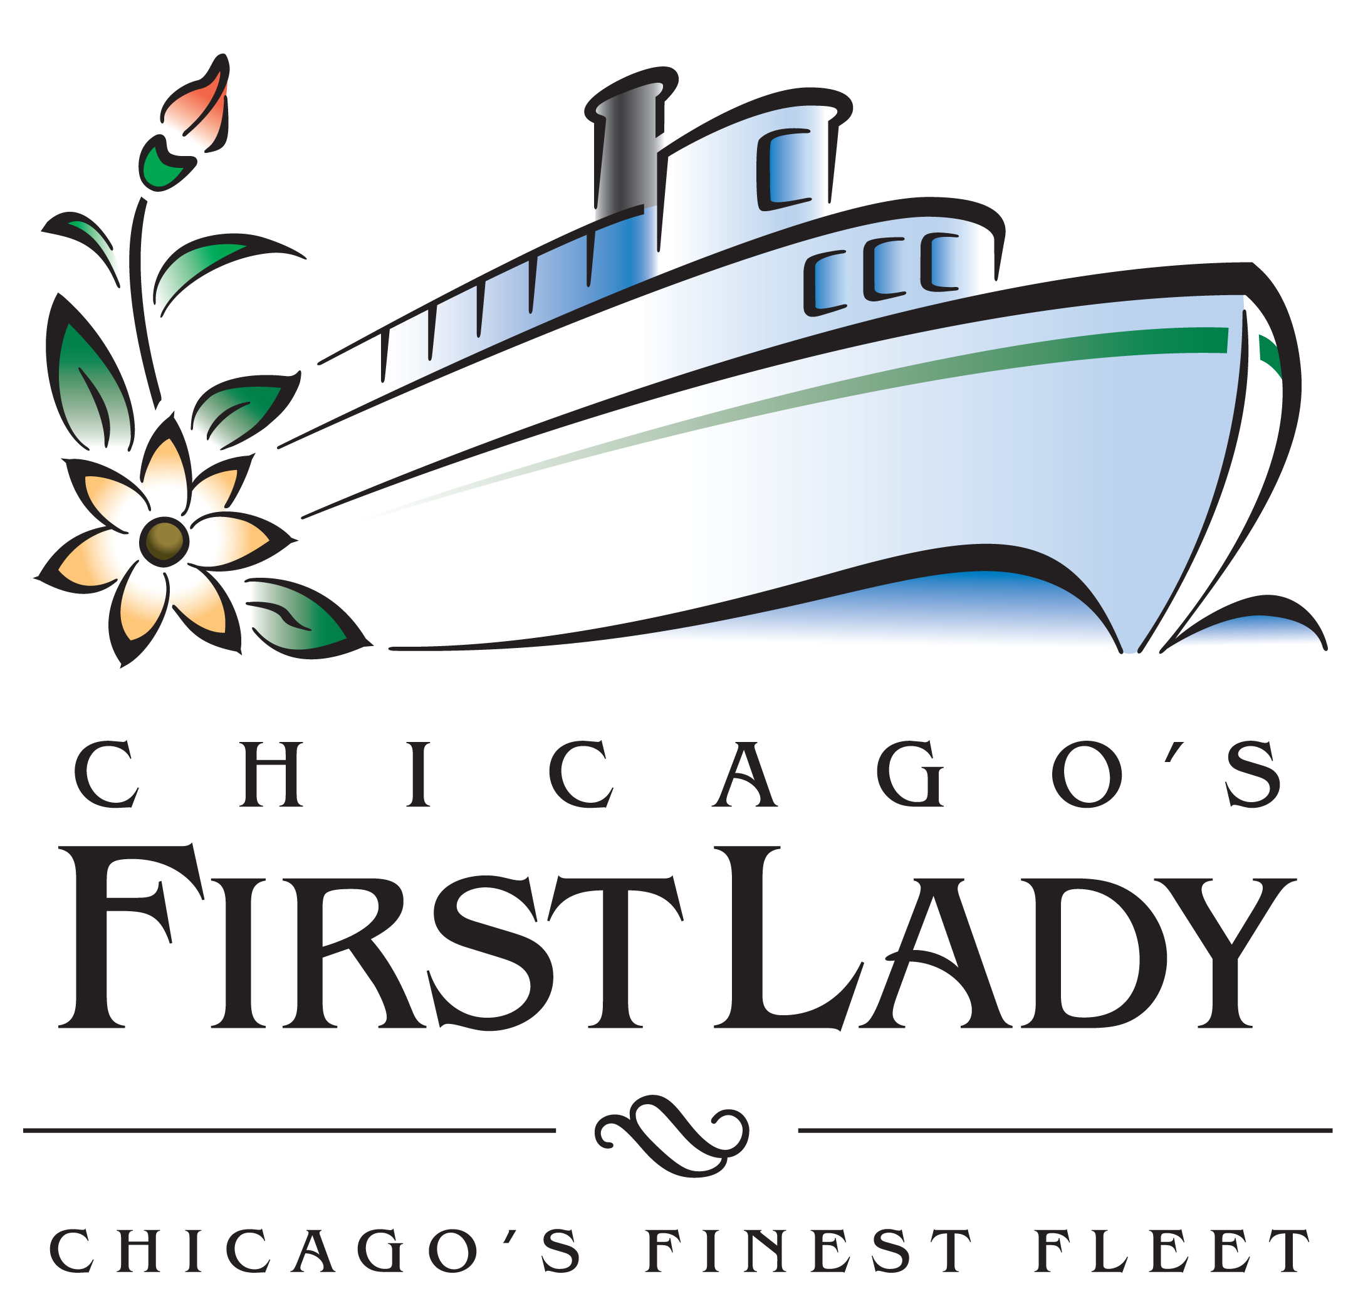 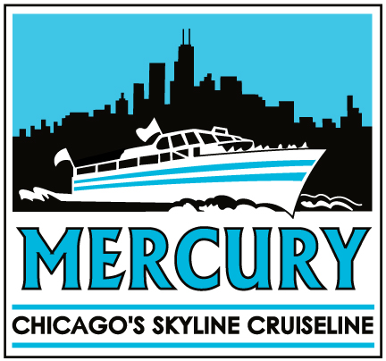

***Welcome Aboard Chicago’s Top Cruise Attractions, Celebrating 81 years of***

***Showcasing Chicago to the World***

2016 season features Chicago favorite cruises: Architecture, 3D Fireworks, Photography, Science and Cruising Canines aboard Chicago’s First Lady Cruises (CFL) and Mercury, Chicago’s Skyline Cruiseline (Mercury) beginning April 2 (CFL) and April 29 (Mercury).

As you plan your 2016 travel coverage, we invite you to consider our exciting cruise line-up aboard **Chicago’s First Lady Cruises** ([www.cruisechicago.com](http://www.cruisechicago.com)), voted one of the ten best tours in the United States by TripAdvisor, and **Mercury, Chicago’s Skyline Cruiseline** ([www.mercurycruises.com](http://www.mercurycruises.com)) family owned and operated by the Agra family. Both cruises showcase Chicago to the world with a variety of family fun and exciting river and lake cruises.

**2016 Cruise Highlights:**

* ***Popular Twilight Cruise Expanded to Five Evenings***: **CAF Twilight River Cruise** aboard Chicago’s First Lady Cruises now departing on five evenings at 7:30pm– Sunday, Monday, Tuesday, Thursday and Friday
* ***Sky-High Sightseeing Doubles the Family Fun!*** **Urban Adventure Package**: **Mercury Plus 360 CHICAGO** offering two panoramic views – from water and sky – for one great price
* ***Canine Cruising All Weekend*: Chicago’s favorite Mercury’s Canine Cruise** now departing Saturdays and Sundays
* ***Land River and Lake Package:*** Combine the ***Urban Adventure Cruise*** with a ***48 hour Hop On Hop Off Bus Tour Ticket*** and explore Chicago from every vantage point
* ***3-D Fireworks Cruise:*** Take an aesthetically stunning tour along ***Chicago’s lakefront with 3-D glasses*** that will provide an unforgettable Chicago visual experience.

All cruises depart from Riverside Gardens, our beautifully landscaped dock on Chicago’s Riverwalk at Michigan Avenue and Wacker Drive,the gateway to Chicago’s Magnificent Mile and just three blocks north of Millennium Park, at 112 E. Wacker Dr.

Following are brief cruise details. You can also access the schedule and download pictures of our beautiful boats by visiting our websites: [www.cruisechicago.com](http://www.cruisechicago.com/) and [www.mercurycruises.com](http://www.mercurycruises.com). Please contact me at mgrimm@hyc.com or 312-274-3593 with questions or for more information.

Sincerely,

Michael Grimm

Chicago’s First Lady Cruises / Mercury, Chicago’s Skyline Cruiseline   
Mobile: 920-904-4973  
Email: mgrimm@hyc.com



**Breathtaking Sky-High Vistas and Spectacular Lakefront Views Aboard   
Mercury, Chicago’s Skyline Cruiseline**

**Canine Cruises, Night Cruises, 3D Fireworks Cruises and more awaits**

**Urban Adventure Cruise** **April 29 – October 10, 2016**

Welcome aboard Mercury’s most popular cruise. This flagship cruise gives passengers a unique view of Chicago’s marvelous skyscrapers, historic buildings and modern marvels.

Enjoy lively narration and stories of Chicago’s rich history. Priceless photography opportunities are abundant as each vessel cruises near iconic structures including Willis Tower, Aon Center, John Hancock Building, Museum Campus and Marina City. This is the quintessential family experience.

Passengers can move about during the cruise to maximize photo and video opportunities as they are treated to a moving, panoramic view of Chicago’s skyline, Buckingham Fountain, Chicago’s Museum Campus with the Adler Planetarium, Shedd Aquarium and The Field Museum, plus passage through the Chicago River Lock System, the world-renowned engineering feat that reversed the river’s flow. After the cruise, families can enjoy strolling along the renovated idyllic Chicago Riverwalk.

**Tickets: $34/adults; $12/children under 12; children under three ride free. Daily cruise departures: 10:15 a.m., 12:15 p.m., 2:15 p.m., 4:15 p.m., 6:15 p.m.** Buy tickets online at MercuryCruises.com or at the dockside ticket window, 112 E. Wacker Dr. on Chicago’s Riverwalk.

**Urban Adventure Package: Mercury Cruise + 360 CHICAGO April 29 – October 10, 2016**

Double Your Family Fun! Experience two views of Chicago’s world-famous lakefront and skyscrapers - panoramic lakefront views aboard Mercury and sky-high vistas from 360 CHICAGO.

One of the best values for families visiting Chicago: for one low price, enjoy a 90-minute lake and river cruise combined with a birds-eye view 1,000-feet up from 360 CHICAGO (formerly John Hancock Observatory), Chicago’s favorite sky-high attraction featuring Tilt* Panoramic 360-degree views, lively cruise commentary and opportunities for family pictures are enjoyed by all in both open-air experiences.

**Tickets: $49/adults; $20/children under 12; children under three are free. Daily cruise departures: 10:15 a.m., 12:15 p.m., 2:15 p.m., 4:15 p.m., 6:15 p.m.** 360 CHICAGO open daily 9 a.m. – 11 p.m. Buy tickets online at MercuryCruises.com or in-person at the Mercury Cruises dock ticket window or 360 CHICAGO box office 875 N. Michigan Avenue. *\*Admission to Tilt not included in package price.*

**3D Fireworks Cruises May 28 – September 3, 2016**

Chicago’s only 3D fireworks experience!

Complimentary 3D glasses for each passenger aboard Mercury’s 3D Fireworks Cruise add a unique perspective to the lakefront fireworks display. The popular 90-minute lakefront fireworks cruise is offered Wednesdays and Saturdays in the summer and offers unobstructed views of the lakefront pyrotechnics. A tour of the lakefront skyline is also featured during this popular cruise. Advance tickets are recommended but also available at the dockside box office.

**2016 Departures: Wednesdays, 8:30 p.m. and Saturdays, 9:00 p.m. Tickets: $35/adults; $13/children under 12; children under three ride free.**

**Chicago by Night May 27 – September 4, 2016**

Millions of twinklinglights reveal unique view of Chicago- Complimentary light wands for each guest

This 90-minute lake and river cruise offers a one-of-a kind view of Chicago, from sensational summer sunsets to Chicago at night with tens of millions of lights bathing the city in a sparkling glow. Each passenger receives a complimentary neon light wand to add his or her own “night lights” to a remarkable skyline panorama. Passengers routinely note the breathtaking view of the Buckingham Fountain during this special night cruise.

**Chicago by Night 2016 Departures: nightly and weekend nights at 8:15 p.m., (excludes Wednesday and Saturday evenings). Weekend nights, September. Tickets: $35/adults; $13/children under 12; children under three ride free.**

**Mercury’s Canine Cruise July 9 - September 25, 2016**

Chicago’s original Canine Cruise now departing Saturdays and Sundays.

Canines and their human companions can now cruise both Saturdays and Sundays as one of Chicago’s most popular activities for the city’s furry friends. To accommodate the cruise’s popularity, weekend departures have been expanded. Mercury’s Canine Cruise, Chicago’s original canine cruise, takes well-behaved dogs and their owners for a 90-minute lake and river tour with lively commentary about dog-friendly Chicago. On-board amenities include large bowls of fresh water and a newspaper-lined restroom.   
  
**Departures: Saturdays and Sundays, 10:15 a.m. Tickets can be purchased in advance online or daily at dockside ticket office. Tickets: $34/adults; $12/children under 12; $8/dogs; children under three ride free. Advance tickets are recommended but also available at dockside box office.**

**New for 2016: Land, River and Lake Package: 90-Minute Cruise + Hop-On Hop-Off Bus Tour**

April 29- October 10

The ultimate discount tour package to explore Chicago from every angle.

See Chicago by boat and by bus and SAVE! Enjoy a **Mercury Urban Adventure Cruise**AND a **48-hour Hop On Hop Off Downtown Tour Ticket with Chicago Trolley & Double Decker Co.**together in the**Land, River and Lake Package.**See Chicago by bus with the award-winning Hop On Hop Off Downtown Tour featuring unlimited boarding at 12 stops along a 13-mile route through the city. All tours are narrated.

**Cruise times**: 10:15am, 12:15pm, 2:15pm, 4:15pm, 6:15pm

Chicago Trolley & Double Decker Co. operates daily 9am - 5pm  
  
**Adults $63 / Kids under 12 $29 / Under 3 free**   
  
*Please note: Land, River & Lake package holders that purchased online at mercurycruises.com must visit Mercury Cruises' box office on the Chicago Riverwalk at 112 E. Wacker Dr. to pick up tickets before visiting Chicago Trolley & Double Decker Co*

**“Science is Fun” Cruise April 29– October 10, 2016**

Student groups have hands-on fun with science!

Buckets of water, balloons, test tubes, pennies and slimy creatures are all part of this 90-minute cruise specially developed for student and camp groups following Illinois Learning and NextGen Science Standards. The cruise offers young Einsteins 90-minutes of non-stop fun as they participate in hands-on experiments to test lake and river waters; learn how a boat floats; how skyscrapers stand up to gravity; what it takes to lift and lower one of Chicago’s famous bridges; and a look at some migrating slimy creatures with Chicago on their radar. Following the scientific method, each question is followed by students offering up their hypotheses and then performing the experiment. Recommended for grade school and middle school students.

**Available only to youth groups of 25 or more. Please call 312-332-1368 for departure dates and times.** Student/Youth Groups of 25 or more **Tickets:** **$13/student; $13/adult**

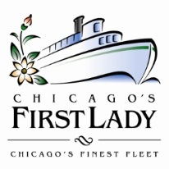

**Chicago Architecture Foundation River Cruise aboard Chicago’s First Lady Cruises**

**Opens 2016 Season on Saturday, April 2**

*The award winning architectural cruise embarks on another highly anticipated season showcasing Chicago to the world*

**Chicago, IL –** Chicago’s First Lady Cruises and the Chicago Architecture Foundation open their 24th season of the heralded **Chicago Architecture Foundation (CAF) River Cruise aboard Chicago’s First Lady Cruises** on Saturday, April 2, sailing with an elite fleet of five luxurious cruise vessels showcasing world-famous architecture in the birthplace of the American skyscraper.

Named one of the “[Top 10 Tours in the United States” by TripAdvisor](http://www.msn.com/en-us/money/other/tripadvisor-shines-a-spotlight-on-the-top-10-tours-in-the-us/ar-AAe8tgE) in 2015, the official Chicago Architecture Foundation River Cruise aboard Chicago’s First Lady Cruises provides the very best way to view and experience one of the world’s greatest global cities and its pioneering architecture. Each tour provides an unparalleled introduction to Chicago’s history by exploring its world-renowned architecture. All cruises feature panoramic city views and highlight more than 50 historic and architecturally significant buildings

As the only Chicago River cruise featuring CAF-trained volunteer-docents, each docent tells the stories of the magnificent riverfront Chicago skyline with fascinating detail and historical overview. Approximately 100 CAF-certified docents volunteer their time and share their passion for architecture featuring the world-famous Chicago skyline including the 108-story Willis Tower, Wrigley Building, Tribune Tower, Marina City, Merchandise Mart, Civic Opera Building and Aqua Tower. After hundreds of hours of training, the CAF-certified volunteer docents lead more than 2,000 cruises per season. The vessels feature open-air upper deck comfortable armchair seating, unparalleled photo opportunities and a temperature controlled interior salon and full-service bar.

Past guests have remarked,

“*This should be at the top of your to-do list in Chicago. The views are wonderful and this is one of the best tours I have taken anywhere.”*

* ChicagoWG1 from TripAdvisor

*“The best way to experience the city.”*

* Jeff L. from Yelp!

“*Many of the sights are breathtakingly beautiful. I absolutely loved our tour guide, Patricia. She was extremely knowledgeable, kind and considerate. It was obvious she loved the city and by the end of the tour, managed to make me and other tourists love the city even more than we did.”*

* Phillip V. from Yelp!

The cruising season begins Saturday, April 2 and runs through Sunday, November 20, 2016 with hourly departures starting at 10am with additional departures on weekends. For a complete schedule, visit [www.cruisechicago.com](http://www.cruisechicago.com). Tickets are $44.00 per person for daytime tours and $46.00 per person for the 7:30pm Twilight Tour. Tickets can be purchased online at [www.ticketmaster.com/rivercruise](http://www.ticketmaster.com/rivercruise); by phone at 800-982-2787 (for calls within the U.S.) or 001-949-333-4001(international calls); at the Chicago’s First Lady dockside ticket office at 112 E. Wacker Dr. (on the Riverwalk at Michigan Ave. & Wacker Dr., look for our blue awnings!); or at the CAF Shop & Tour Center (224 S. Michigan Ave.). For groups of 10 or more, please contact the Group Tour Sales Department at 312-322-1131 or via email: [grouptours@architecture.org](mailto:grouptours@architecture.org). For more information, visit [www.cruisechicago.com](http://www.cruisechicago.com/) or [www.architecture.org](http://www.architecture.org).

###

**About Chicago’s First Lady Cruises**

Chicago’s First Lady Cruises is the first name in Chicago cruises and is a fourth generation family owned and operated Cruiseline leading a fleet of 6- custom built passenger vessels, designed and constructed in the United States. Chicago’s First Lady Cruises and its parent company, Mercury Chicago’s Skyline Cruiseline, are celebrating their 81st season on the banks of the Chicago River and with the Chicago Architecture Foundation. Inspected annually by the US Coast Guard, Chicago’s First Lady’s fleet proudly sails on the Chicago River and Lake Michigan harbor front. As longtime stewards of Chicago’s waterways, Chicago’s First Lady Cruises has committed to green initiatives that make all of its vessels carbon neutral and energy and environmentally friendly, utilizing only clean resources including B-11 biodiesel fuel. All vessels are available for private charter cruising and special events complete with food and beverage for groups of 2 – 250. For more information, visit [www.cruisechicago.com](http://www.cruisechicago.com/) or call 1-847-358-1330.

Connect with us on [Facebook.com/CruiseChicago](https://www.facebook.com/cruisechicago/), [Twitter.com/CFLcruises](https://twitter.com/CFLcruises), [Pinterest.com/CFLcruises](https://www.pinterest.com/CFLcruises) and [Instagram.com/CFLcruises](https://instagram.com/CFLcruises/).

**About Chicago Architecture Foundation**

The Chicago Architecture Foundation is a nonprofit organization dedicated to inspire people to discover why design matters. The CAF pursues this mission through architecture tours, exhibitions, panel discussions and youth and adult education programs. A permanent exhibition, *Chicago Model City*, includes a highly detailed scale model of Chicago. CAF is located at 224 S. Michigan Avenue, Chicago, Illinois 60604. For further information, visit [http://www.architecture.org](http://www.architecture.org/) or call 1-312-922-3432 or become a Facebook fan: <http://www.facebook.com/chiarchitecture> or follow on Twitter: <http://www.twitter.com/chiarchitecture> or follow on Pinterest: <http://www.pinterest.com/chiarchitecture> or Linkedin: <http://www.linkedin.com/company/chicago-architecture-foundation>.